## Lab 0 Assignment:

**Once Vivado is downloaded on your computer, watch the “Intro to Vivado” video on Poly Learn. I recommend performing each step shown in the video on your computer as you are watching it.**

**After completing synthesis, simulation, implementation and bit stream generation successfully as shown in the video, download your design to your BASYS3 board.**

**Demo that your lab 0 design works 100% on a BASYS3 board.**

**100% working for this design means your design performs the truth table shown below.**

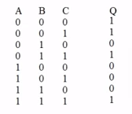

**Also, open “Elaborated Design” and verify your schematic looks like the schematic below.**

